Chart ##: Chart Title
Chart Heading
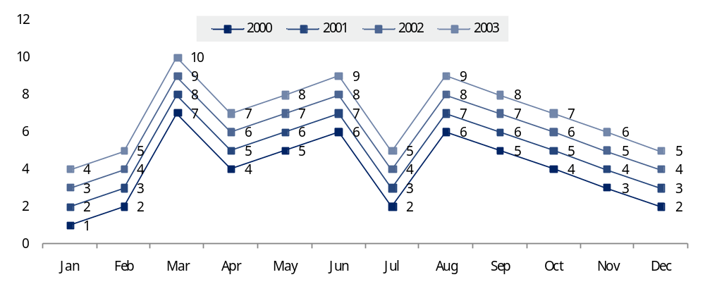
Chart Note Dark (Chart Note Light )

